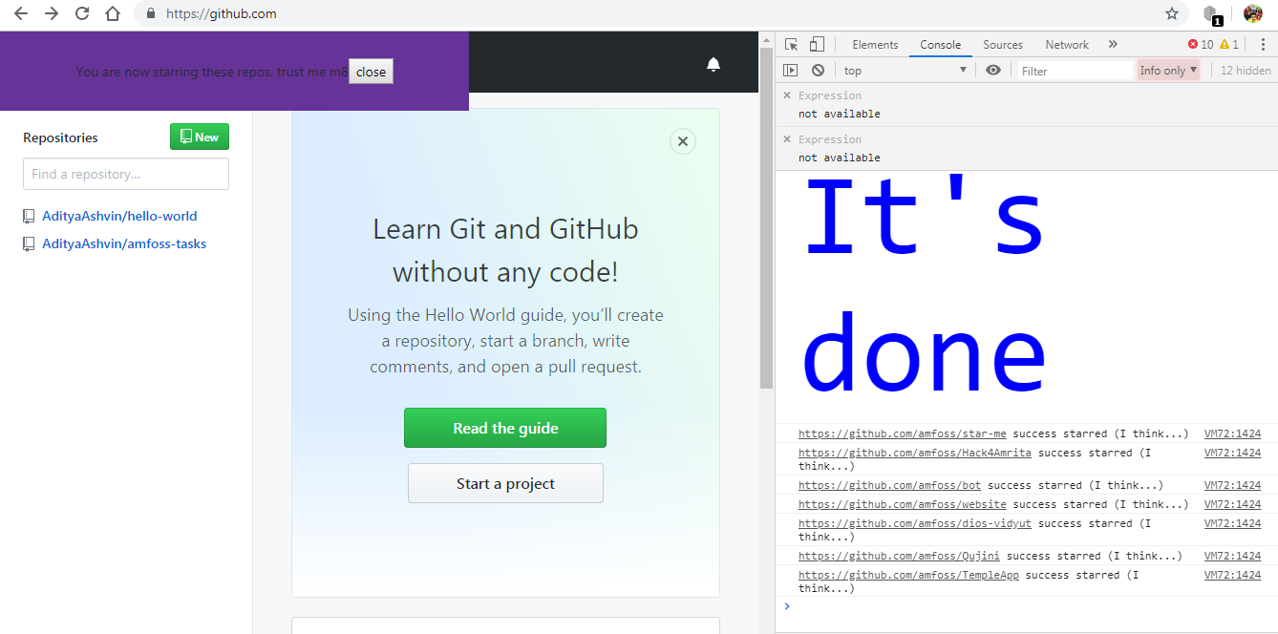TASK 1

Star all the amfoss repositories